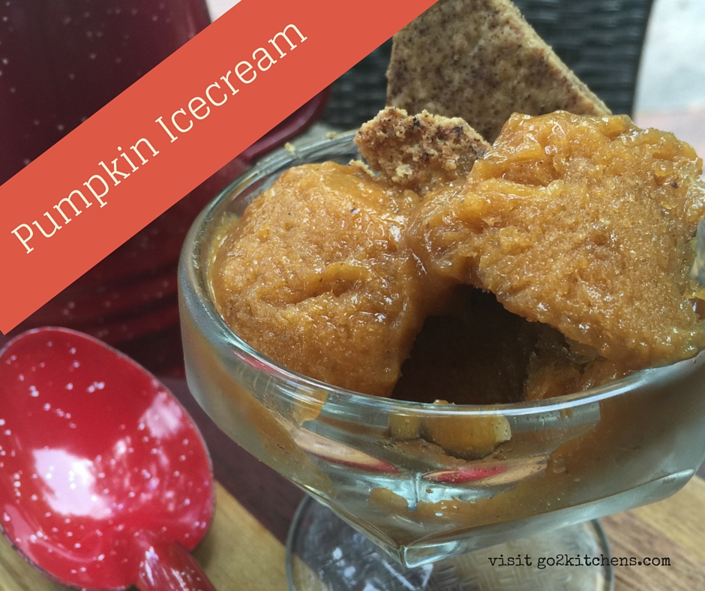

Ingredients:
4 Organic Bananas – Peeled
1 Cup 100 % Pumpkin Puree (Not Pumpkin Pie Filling and no added sugar)
1/3 Cup Maple Syrup
1 TSP of Pumpkin Pie Spice

Place all ingredients in blender and blend until smooth. Place in freezer safe container and cover. Ready to serve in 2-4 hours.

