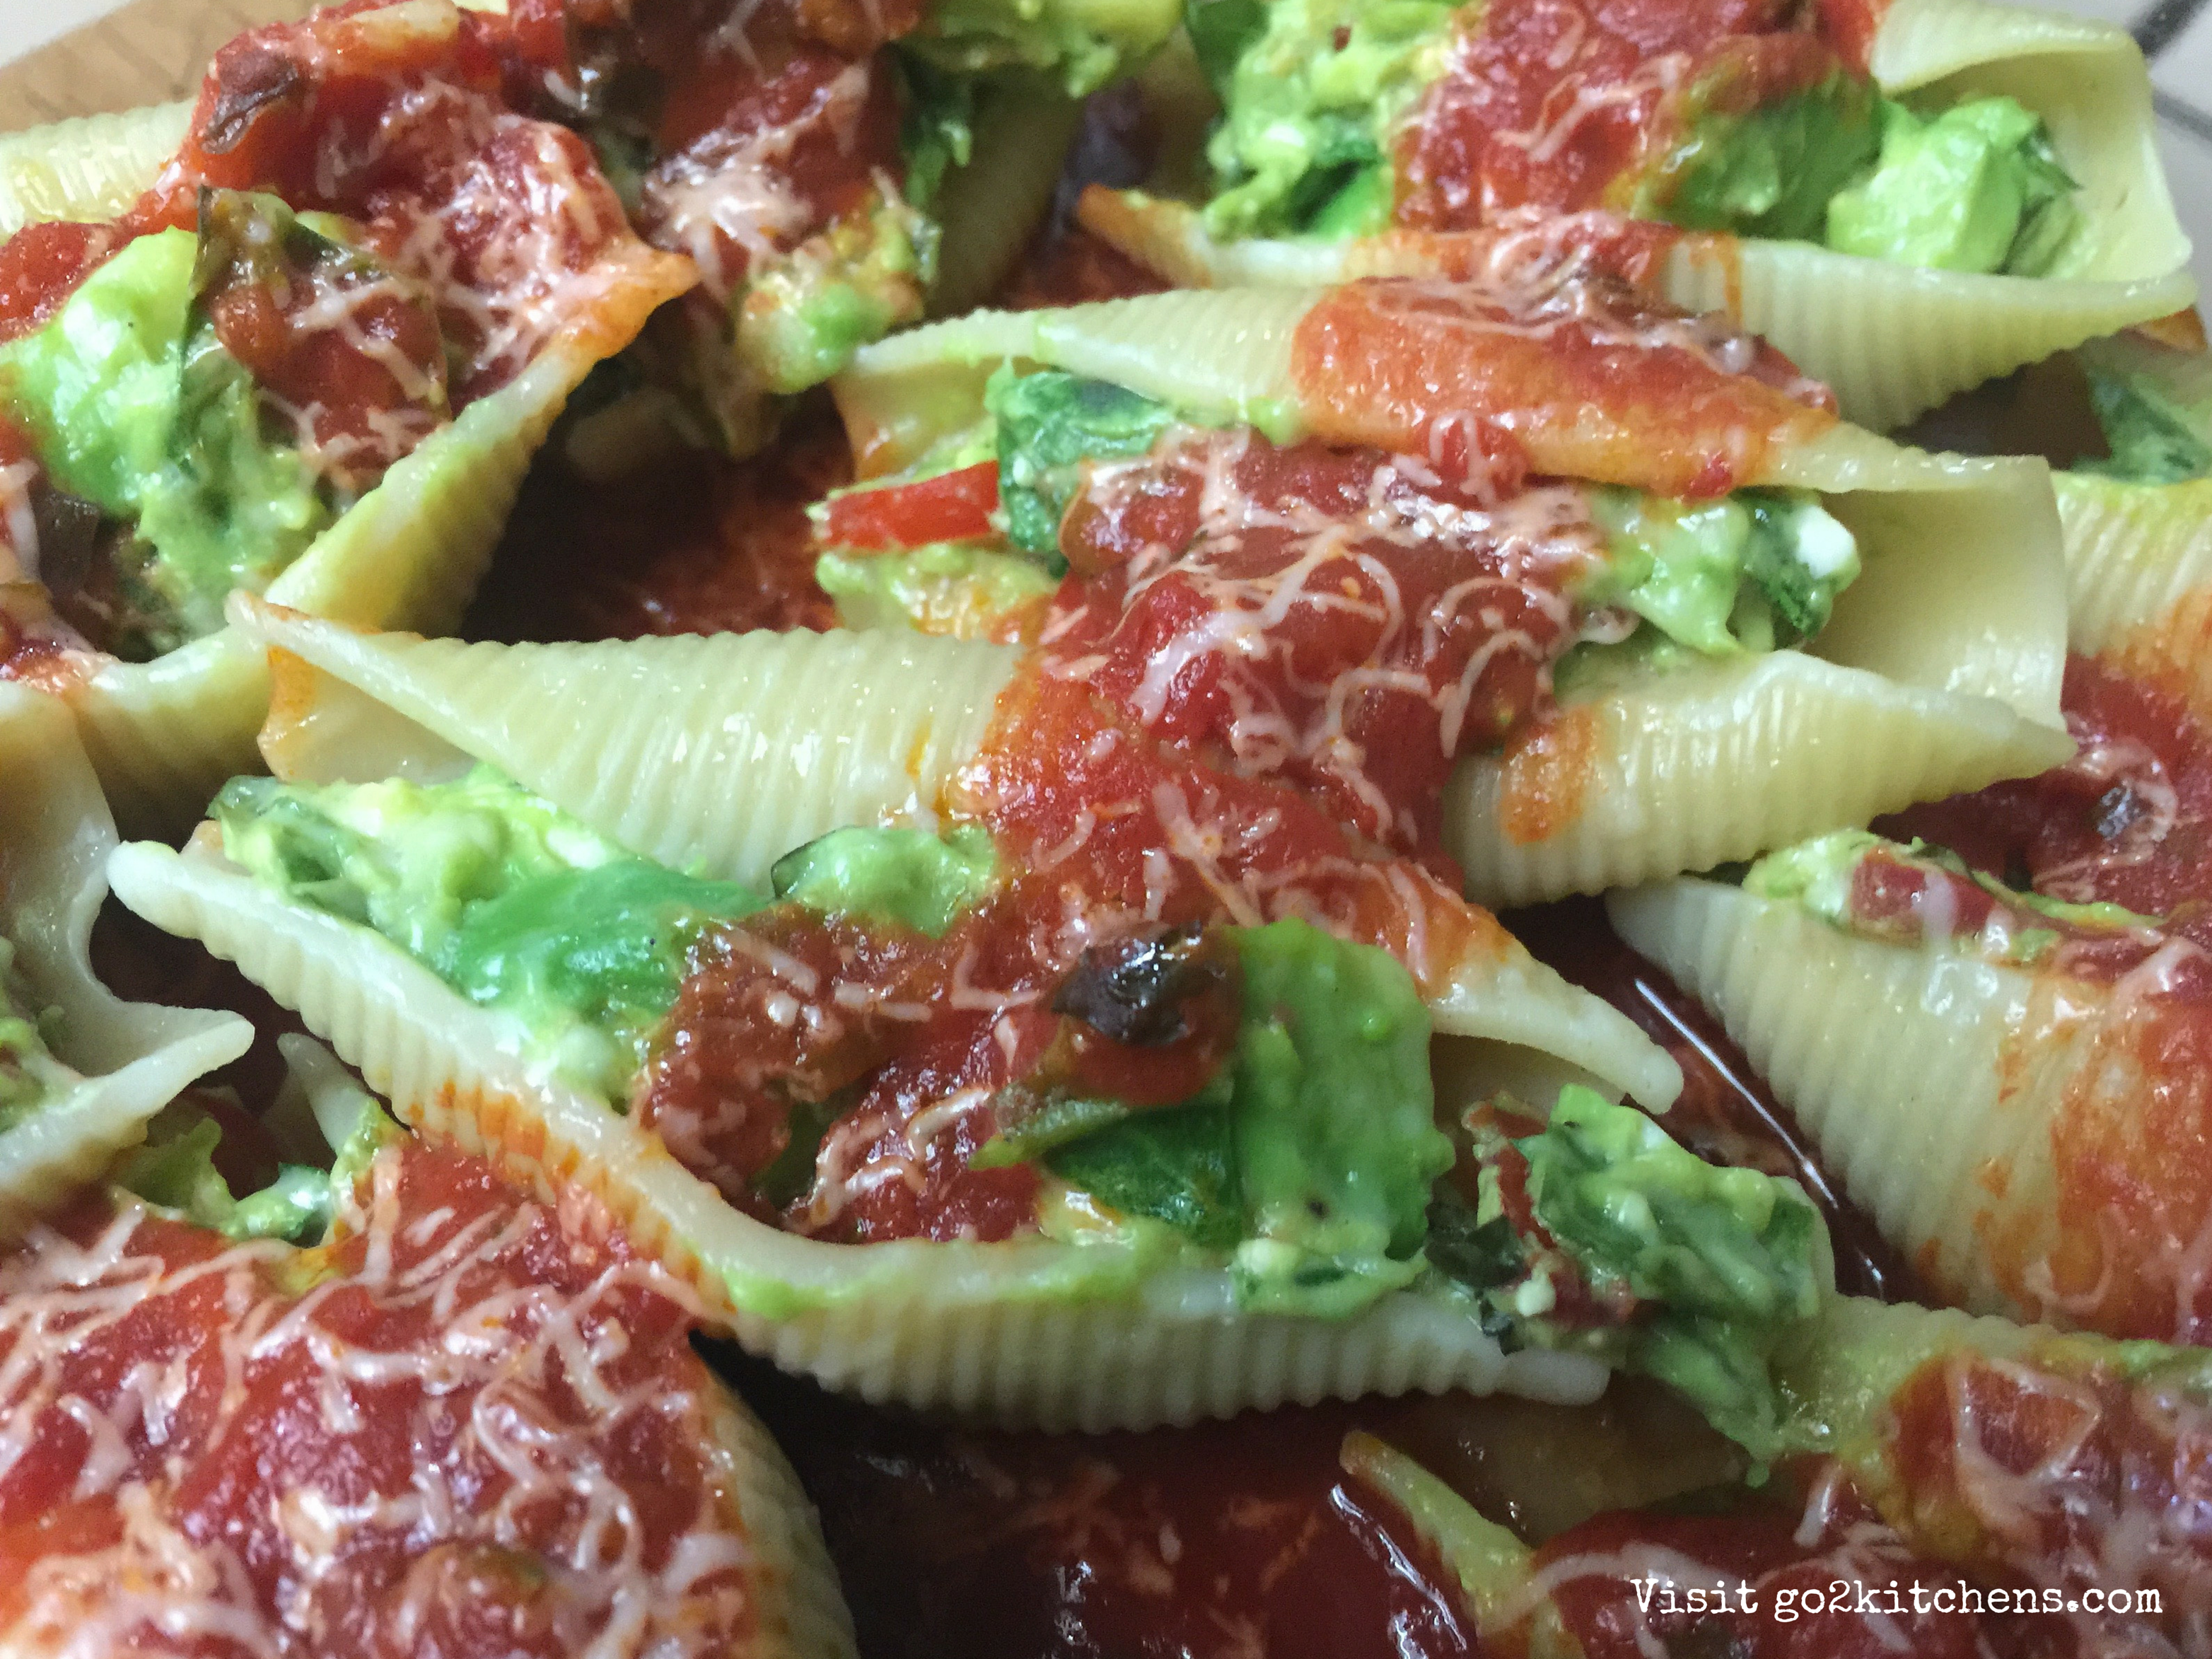
Italian Avocado Stuffed Shells
Ingredients:
12 Pasta Shells - cooked to al-dente
2 Avocados, pitted
2 TBS of Feta Cheese
2 Cloves of Garlic, finely chopped
1 TBS of Fresh Basil, finely chopped
1 TBS of Fresh Parsley, finely chopped
1/3 Cup Baby Spinach, chopped
6-8 Grape Tomatoes, sliced
Salt and Pepper to Taste
1/2 - 1 cup Marinara

Pre-heat oven to 350. Cook shells according to package, drain and let cool. Combine avocado, feta, basil, parsley, spinach, tomatoes, salt and pepper. Mash until well blended but not smooth. Stuff shells with the combined ingredients. Spoon some marinara in a baking dish large enough to hold all the shells, then line up the stuffed shells in single layers. Top with more marinara. Cover loosely with foil and bake for 20 mins. Garnish with parsley and even some parmesan cheese.

